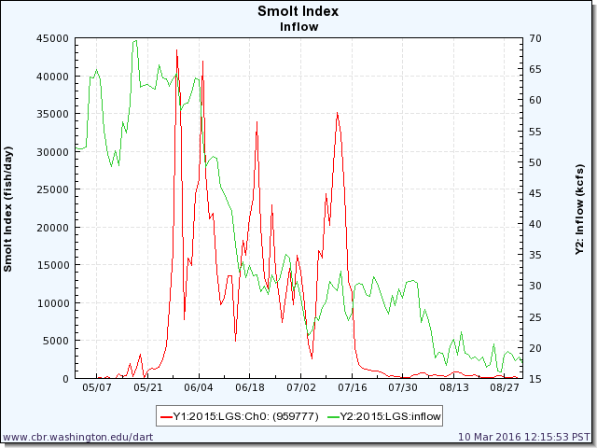

RSW maintained: 6/19 – 7/17; 49% of smolt index affected.

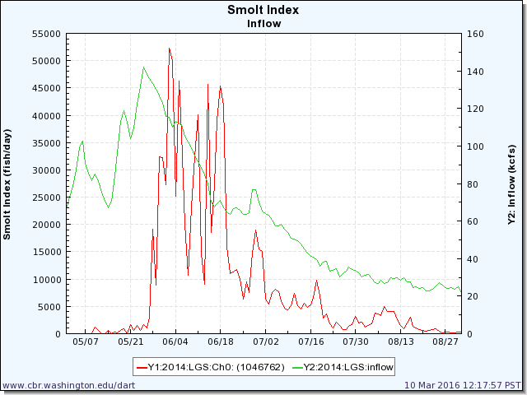

RSW maintained: 7/13 – 7/24; 5% of smolt index affected.

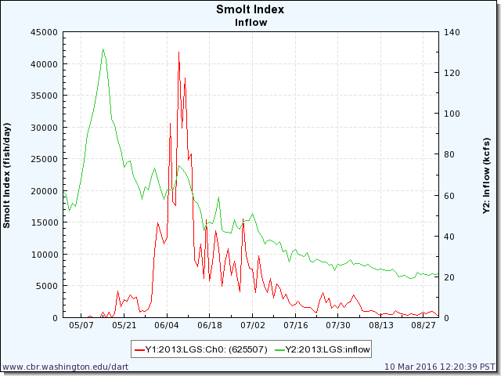

RSW maintained: 6/22 – 7/17; 25% of smolt index affected.

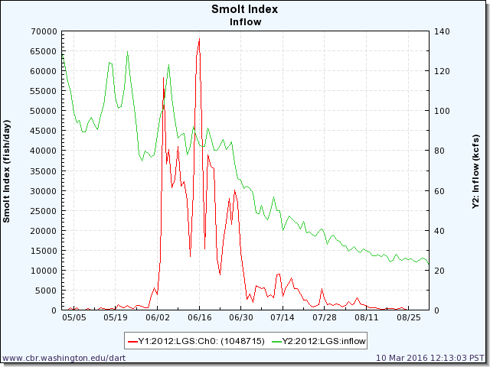

RSW maintained: 7/13 – 7/22; 5% of smolt index affected.

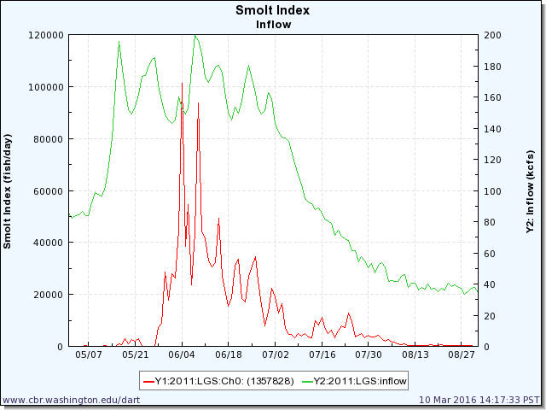

Criteria not met.

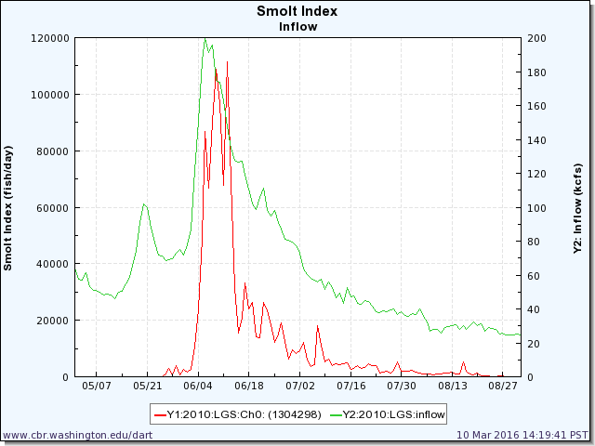

RSW maintained: 7/12 – 7/18; 2% of smolt index affected.

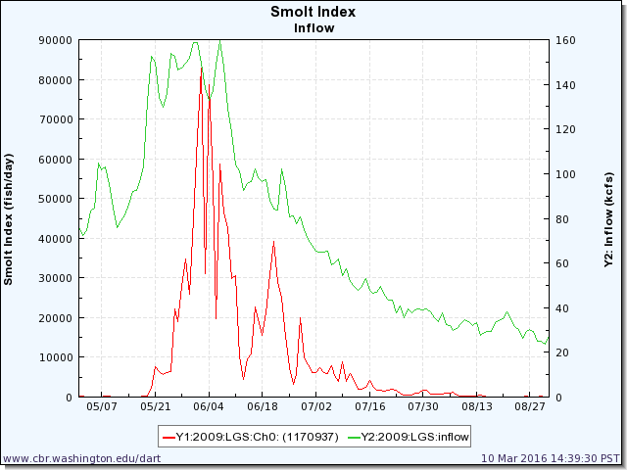

Criteria not met.

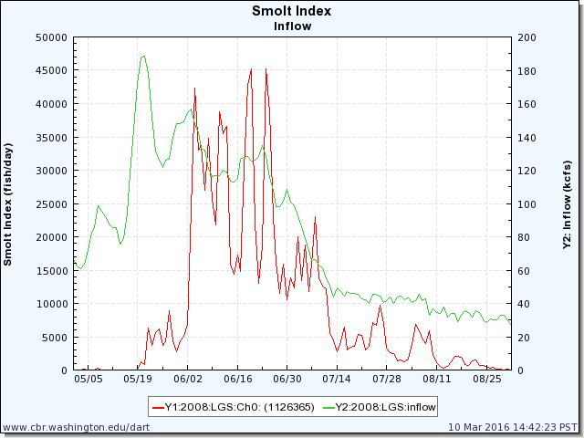

RSW maintained: 7/13– 7/16; 1% of smolt index affected.

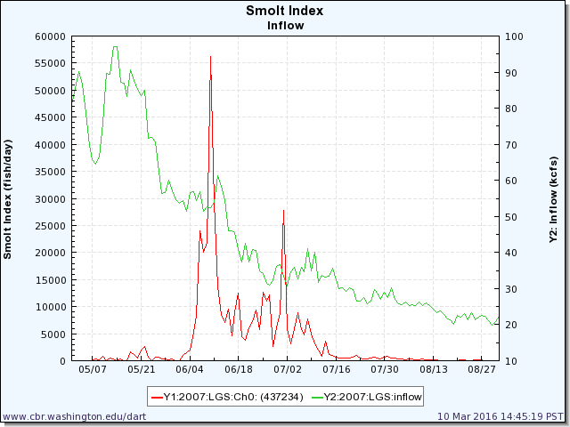

RSW maintained: 6/19 – 7/14; 40% of smolt index affected

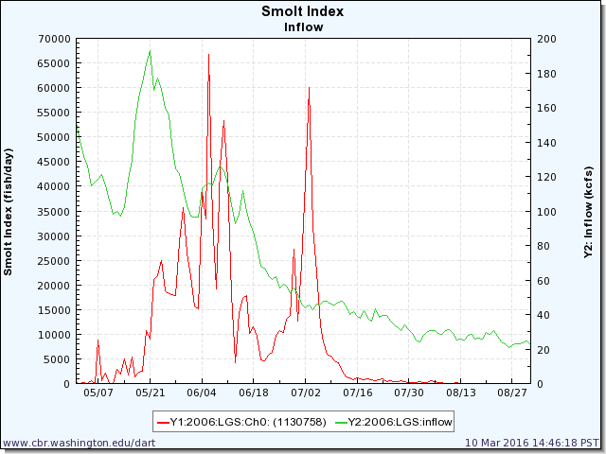

RSW maintained: 7/1 – 7/14; 20% of smolt index affected